



*“The Great Adventure”*

1 / 29 /23

Genesis 12: 1 – 5 (NIV)

“The Lord had said to Abram, “Go from your country, your people and your father’s household to the land I will show you.

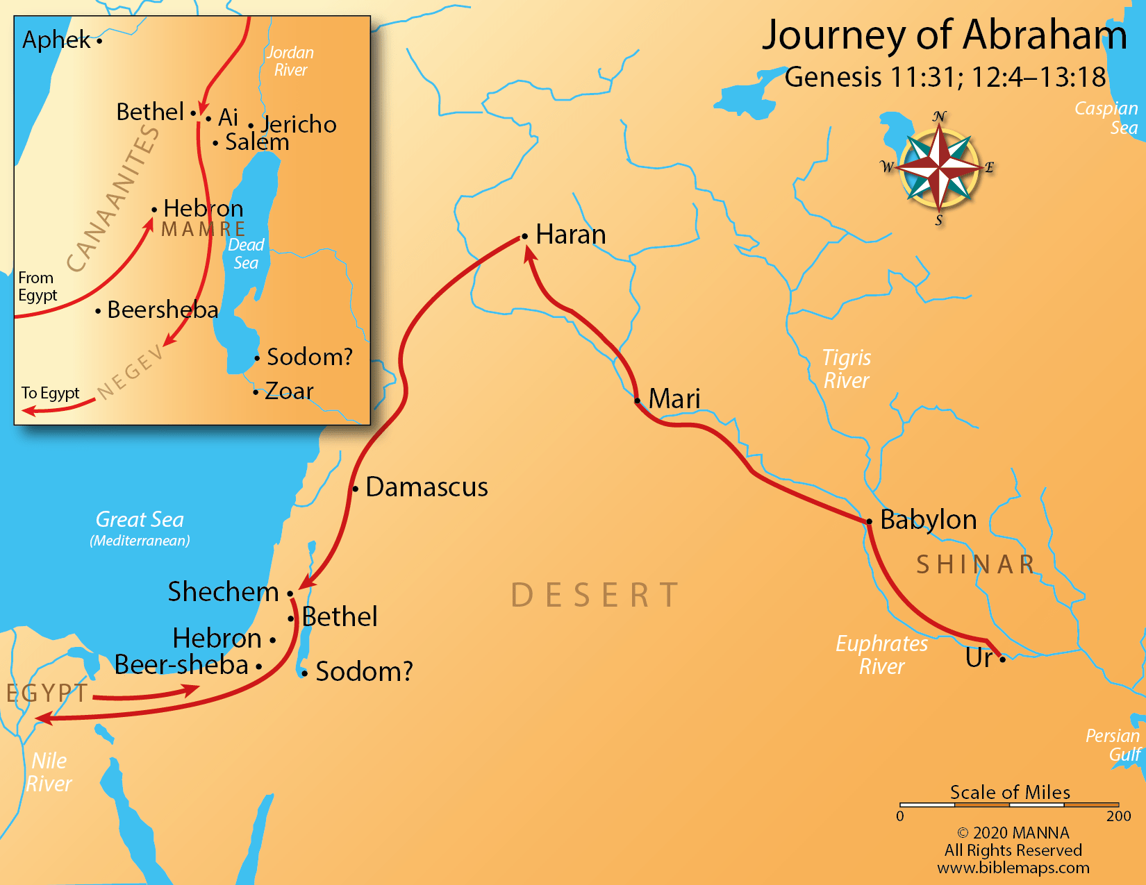**2**“I will make you into a great nation,  and I will bless you;  
I will make your name great,  
    and you will be a blessing.   
**3**I will bless those who bless you,  and whoever curses you I will curse; and all peoples on earth will be blessed through you.”

**4**So Abram went, as the Lord had told him; and Lot went with him. Abram was seventy-five years old when he set out from Harran. **5**He took his wife Sarai, his nephew Lot, … and they set out for the land of Canaan, and they arrived there.”

Hebrews 11:8 (NASB)

“By faith Abraham, when he was called, obeyed by going out to a place which he was to receive for an inheritance; and he left, not knowing where he was going.”

**God wanted Abram to recognize that his security didn’t lie in his ______________ or his _________________, but in _________.**

Hebrews 12:1 (LB)

“Since we have such a huge crowd of men of faith watching us from the grandstands, let us strip off anything that slows us down or holds us back, and especially those sins that wrap themselves so tightly around our feet and trip us up; and let us run with patience the particular race that God has set before us.”

**Two things that keep us from having a**

**“whatever it takes” mindset with God:**

**____________________ of ___________________**

**Getting ____________________**

**Three questions we all have to answer:**

**What is God ___________________ _______ to?**

**What is _________________ me ___________?**

**Am I going to be willing to____________ Him _____________ He ___________?**